Assignment –1

Creating sample tables and inserting values.

Create the following tables with the given structures and insert sample data as specified: -

A) SALESPEOPLE

Snum int(4)

Sname varchar(10)

City varchar(10)

Comm float(3,2)

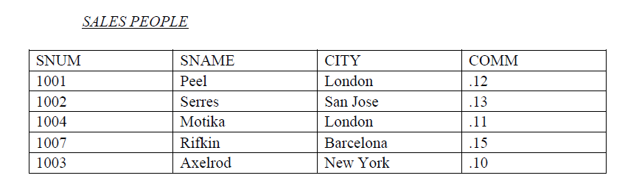

**Ans=>**

/*create database assignment;*/

use assignment;

/*

create table SALESPEOPLE

(

Snum int(4),

Sname varchar(10),

City varchar(10),

Comm float(3,2)

);

insert into SALESPEOPLE values(1001,'Peel','London',.12),

(1002,'Serres','San Jose',.13),

(1004,'Motika','London',.11),

(1007,'Rifkin','Barcelona',.15),

(1003,'Axelrod','New York',.10);

B) CUSTOMERS

Cnum int(4)

Cname varchar(10)

City varchar(10)

Rating int(4)

Snum int(4)

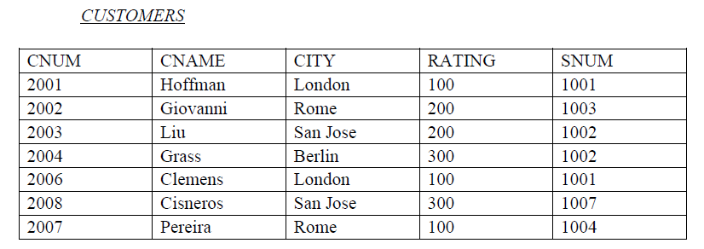

**Ans=>** create table CUSTOMERS

(

Cnum int(4),

Cname varchar(10),

City varchar(10),

Rating int(4),

Snum int(4)

);

insert into CUSTOMERS values(2001,'Hoffman','London',100,1001),

(2002,'Giovanni','Rome',200,1003),

(2003,'Liu','San Jose',200,1002),

(2004,'Grass','Berlin',300,1002),

(2006,'Clemens','London',100,1001),

(2008,'Cisneros','San Jose',300,1007),

(2007,'Pereira','Rome',100,1004);

C) ORDERS

Onum int(4)

Amt float(7,2)

Odate date

Cnum int(4)

Snum int(4)

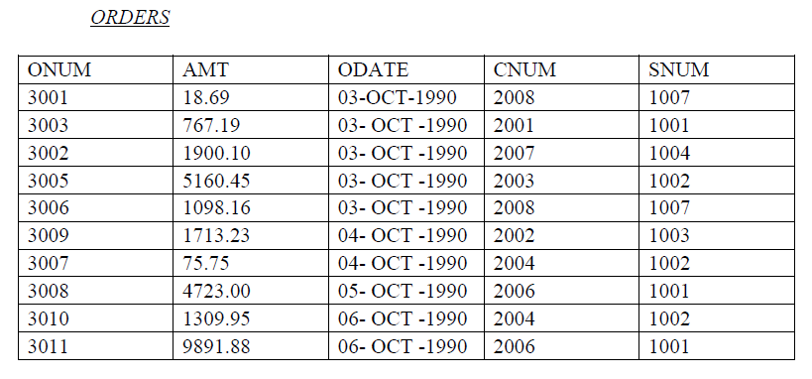

**Ans=>**

create table ORDERS

(

Onum int(4),

Amt float(7,2),

Odate date,

Cnum int(4),

Snum int(4)

);

insert into ORDERS values(3001,18.69,'1990-10-03',2008,1007),

(3001,18.69,'1990-10-03',2008,1007),

(3003,767.19,'1990-10-03',2001,1001),

(3002,1900.10,'1990-10-03',2007,1004),

(3005,5160.45,'1990-10-03',2003,1002),

(3006,1098.16,'1990-10-03',2008,1007),

(3009,1713.23,'1990-10-03',2002,1003),

(3007,75.75,'1990-10-03',2004,1002),

(3008,4723.00,'1990-10-03',2006,1001),

(3010,1309.95,'1990-10-03',2004,1002),

(3011,9891.88,'1990-10-03',2006,1001);